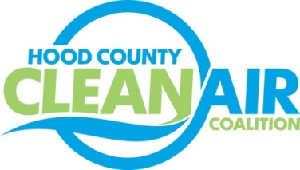
Meeting: Thursday, May 4, 2017
Neely House
304 East Rucker Street, Granbury, Texas 76048
8:30-10:00 a.m.

Agenda

- Call Meeting to Order
- EPA Updates – Randy Pitre
- Regional Updates – Michelle McKenzie
  - Air North Texas Clean Air Action Day on June 23, 2017 www.airnorthtexas.org/cleanairactionday
  - EPA Seeks Input on Regulations https://www.epa.gov/laws-regulations/regulatory-reform
  - Air Quality Funding Opportunities: www.nctcog.org/aqfunding
i.) Fleets for the Future Bootcamp May 24, 2017 www.nctcog.org/f4f
ii) EPA National Clean Diesel Funding Assistance Program RFP
- Local Updates – Michelle McKenzie
  - Review of April Meeting Summary
  - Review of Projects
    - Monthly Budget Review for March
    - Status of Projects FY 16/17
    - Annual Minutes
7.) Discussion
8.) Adjourn

